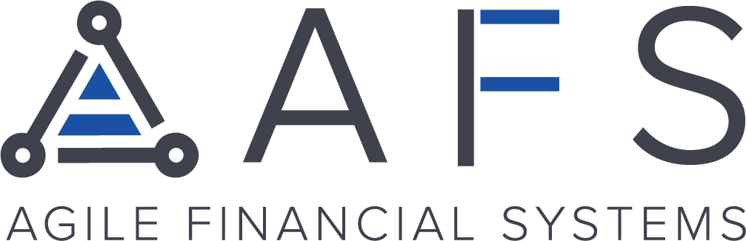
Boost Consumer Spending Power for Your
Merchants with LendingPoint
Hey {NAME},
AFS is thrilled to partner with LendingPoint to provide merchants with a superior lending alternative to traditional buy now, pay later providers.
With a seamless mobile application process, customers can access between $500-10,000 no interest for 90 days, with a 3% fee.
How it works:
LendingPoint creates better financial borrowing experiences by employing its AI CreditTech platform to understand the unique credit history of every applicant with near-instant decisioning.
Why it’s the best option for you and your merchants:
LendingPoint Pay opens businesses up to more revenue by unlocking the most secure and merchant friendly pay-over-time platform accessed from anywhere.
Merchants can enroll at zero cost per transaction with a 25BPS rebate with every approved transaction.
That’s not all. As an agent, you are rewarded with 50BPS on your monthly residuals per approved transaction with your merchants. Now both you and your merchants can earn even more revenue.
So what are you waiting for?
Diversify your offerings with this easy-to-close solution that maximizes revenue and reach. Enroll with LendingPoint today at zero cost to you or your merchants.
Start Here!

