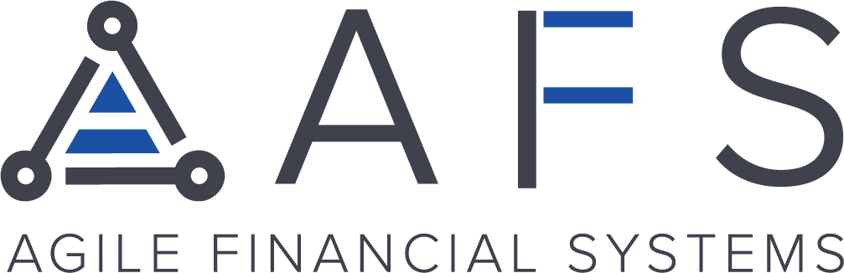
Boost Your Consumer’s Spending Power
with LendingPoint
Hey {NAME},
AFS is thrilled to partner with LendingPoint to provide you with a superior lending alternative to traditional buy now, pay later (BNPL) providers.
With a seamless mobile application process, your customers can access between $500-10,000 no interest for 90 days, with a 3% fee.
How it works:
LendingPoint creates better financial borrowing experiences by employing its AI CreditTech platform to understand the unique credit history of every applicant with near-instant decisions.
Why it’s the best option for your business:
LendingPoint Pay opens businesses up to more revenue by unlocking the most secure and merchant friendly pay-over-time platform accessed from anywhere.
Traditional BNPL providers can charge up to 6% in merchant fees per transaction. With LendingPoint Pay, merchants can enroll at zero cost per transaction.
That’s not all. You get a 25BPS rebate added to your monthly statement with every approved transaction.
So what are you waiting for?
By enrolling in LendingPoint Pay today, you get paid to save. Zero fees, maximized revenue, and instant rebates.
Start Here!

